

NOVAC TECHNOLOGY SOLUTIONS

User Manual

Document Version No.: 1.00

Revision History
Version No | Reason For Changes | Author | Approver
0.01 | Draft | Anurag Kumar
1.00 | Reviewed & Approved the User Manual | Anurag Kumar | NIJANTHAN PL

Table of Contents
1. Introduction 4
2. New warrantee clauses are required (ANIMAL BITE COVER (FOR DEATH ONLY) 4
3. Changes in the “MOTORCYCLING INCLUSION” wording 5
4. Validation in the DOB field 6
5. Policy period in the Output documents 6

Introduction

As per the requirement, new changes are required in the IPA product distribution.
- Guidelines, circulars, instructions and directions released from time to time by Philippines Insurance council.

Functional Overview

System is expected to add a new warrantee clause and changes are required in the existing warrantee wordings and validations.

New warrantee clauses are required (ANIMAL BITE COVER (FOR DEATH ONLY)

- System should auto default the ANIMAL BITE COVER (FOR DEATH ONLY) warrantee when select the ANIMAL BITE COVER (FOR DEATH ONLY) Cover.

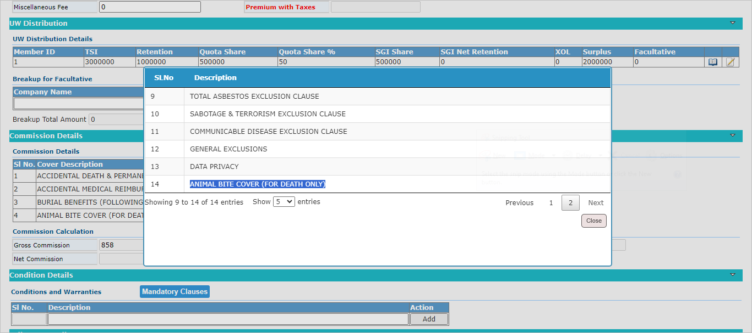

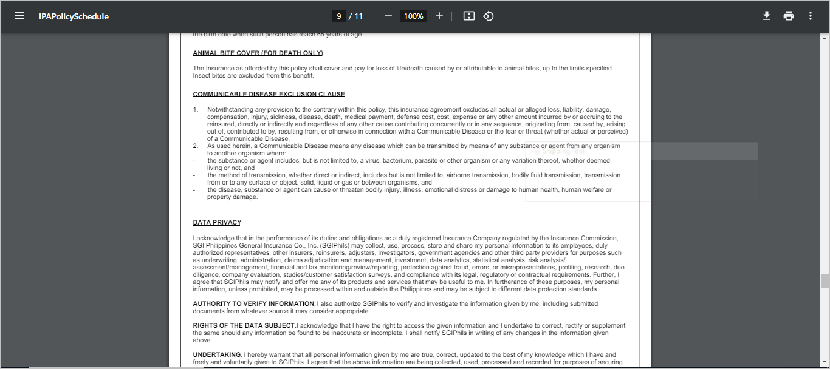

Changes in the “MOTORCYCLING INCLUSION” wording

- System should display the wording description for MOTORCYCLING INCLUSION Warrantees, which is attached in the reference section
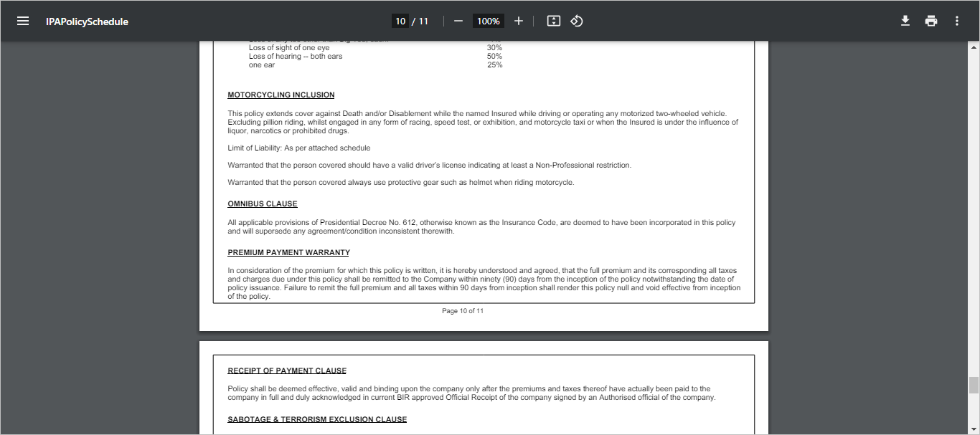

Validation in the DOB field

- In the current system, System shows the error message when age (DOB) is beyond 70 years old. Now system is required to show the error message if the age is greater than 65 years old.

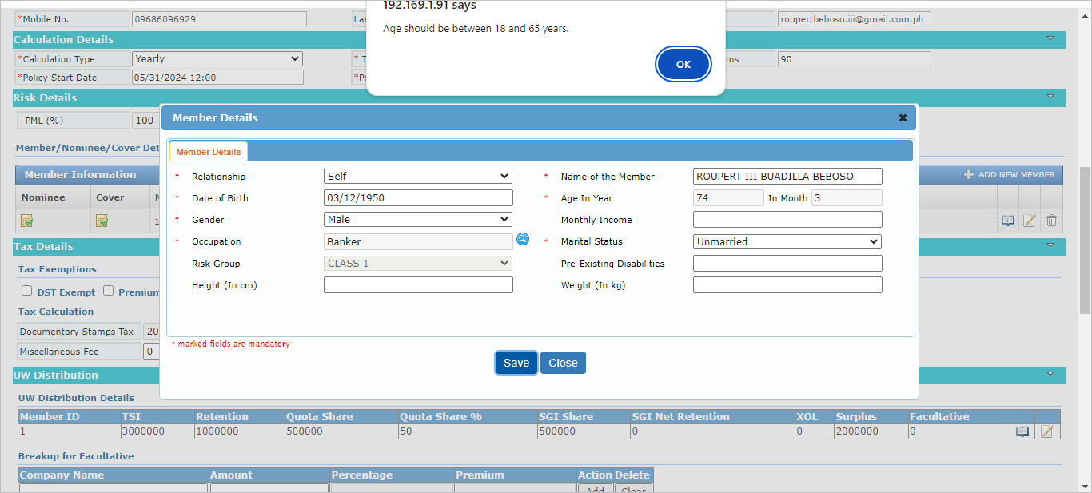

Policy period in the Output documents

- System should display the “AM” instead of “NN” in policy period columns for all output documents for IPA product.

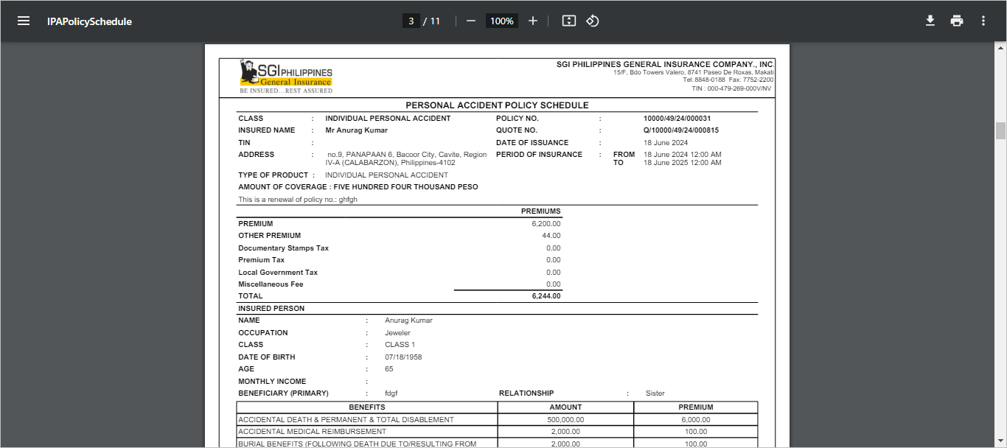

Click on Close button to close the window.

